Dissipative Softening of Chern Plateaus
in a Two-Sector Lattice Dirac Model

Abstract
We present a rigorous low-energy effective field theory for topological materials based on the Qi–Wu–Zhang (QWZ) lattice Dirac model. By coupling the system to a Lindblad dephasing bath with jump operator L = σz—representing quasi-static strain or crystal-field fluctuations—we derive a closed-form expression for the dissipatively softened Hall conductivity σ²ᵉᶠᶢ(M,γ). The central result is a momentum-dependent damping factor that acts directly on the spectral weight rather than the Fermi distribution, producing momentum-selective suppression tied to the local band gap E(k) = |d(k)|. We demonstrate that the M = 0 topological transition exhibits an enhanced suppression relative to the M = ±2 transitions—a doubled cusp effect consistent with the simultaneous gap closure at two high-symmetry points in the Brillouin Zone. The phase map σ²ᵉᶠᶢ(M,γ) constitutes the central falsifiable prediction of this work. A fully vectorized numerical implementation is provided, verified to Chern number quantization error ε < 10⁻⁴.

Keywords: topological insulators, Chern number, Lindblad master equation, Hall conductivity, dephasing, open quantum systems, QWZ model, Berry curvature

1. The Lattice Model: Qi–Wu–Zhang Hamiltonian
We define our system on a square lattice using the two-band Dirac model. The Bloch Hamiltonian H(k) is constructed from the d-vector d(k) = (dx, dy, dz):
H(k) = d(k) · σ = dx(k)σx + dy(k)σy + dz(k)σz
The three components of the d-vector are parameterised as:
- dx(k) = sin kx
- dy(k) = sin ky
- dz(k) = M + cos kx + cos ky

The mass parameter M controls the relative orbital energy offset and drives topological phase transitions at gap closures located at the high-symmetry points Γ = (0,0), M = (π,π), and X/Y = (π,0)/(0,π).

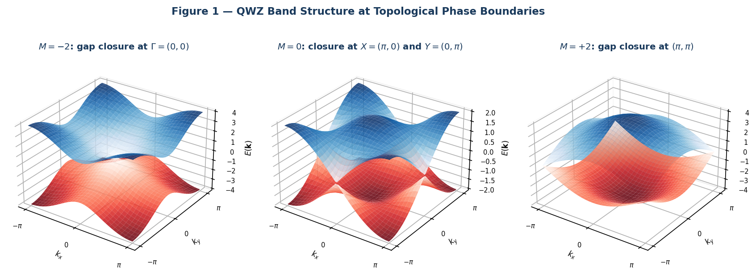
Figure 1. Energy band structure E(k) of the QWZ model at the three topological phase boundaries. Left: M = −2, gap closes at Γ. Centre: M = 0, simultaneous closure at X = (π,0) and Y = (0,π). Right: M = +2, closure at (π,π). Upper (blue) and lower (red) bands touch at zero energy at these momentum-space locations.

2. Topological Invariants: Berry Curvature and Chern Number
In the closed-system limit (γ = 0), the topological character of each band is encoded in the Berry curvature Ω(k):
Ω(k) = (1/2) · [d · (∂kx d × ∂ky d)] / |d|³
The Chern number C is the integral of Ω(k) over the full Brillouin Zone (BZ):
C = (1/2π) ∫_BZ Ω(k) d²k
Integration yields three topologically distinct phases:

Parameter Range | Chern Number C | Phase
−2 < M < 0 | C = +1 | Topological
0 < M < 2 | C = −1 | Topological
|M| > 2 | C = 0 | Trivial insulator

3. Dissipative Dynamics: Lindblad Dephasing

3.1 Physical Justification of the Jump Operator
We adopt the Lindblad operator L = σz to model quasi-static fluctuations in the local gap parameter dz(k). In topological semiconductor heterostructures such as HgTe/CdTe, these correspond to strain-induced or disorder-driven fluctuations in the crystal field that shift the relative energy of the two orbital sectors without inducing coherent spin-flip transitions (σx, σy). This diagonal noise is the leading-order decoherence mechanism in the relevant material class. We assume a quasi-static dephasing regime in which the environmental fluctuation timescale τenv satisfies τenv ≫ τφ (the electronic coherence time), justifying a Markovian master equation with a momentum-independent dephasing rate γ. The momentum-independence is a mean-field approximation that breaks down in the presence of strongly k-dependent disorder; this regime is discussed in Section 4.

The Lindblad master equation for the reduced density matrix ρ is:
ρ̇ = −i[H, ρ] + γ (σz ρ σz − ρ)
The dephasing term induces decoherence between the band sectors without generating coherent transitions. Unlike thermal broadening, which modifies the quasiparticle occupation through the Fermi distribution, the present mechanism acts directly on the spectral weight, producing a momentum-selective suppression tied to the local band geometry. This distinction is demonstrated explicitly in Section 6.

4. Effective Hall Response: Derivation and Validity

4.1 Kubo–Bastin Starting Point
The Hall conductivity σₓʸᵉᶠᶢ in the Kubo–Bastin formalism is expressed in terms of retarded and advanced Green's functions Gᴿᐟᴬ as:
σₓʸᵉᶠᶢ ∝ Tr ∫ dε f(ε) [ vx (dGᴿ/dε) vy (Gᴿ − Gᴬ) − vx (Gᴿ − Gᴬ) vy (dGᴬ/dε) ]

4.2 Self-Energy Approximation
Lindblad dephasing at rate γ is incorporated by replacing the infinitesimal convergence factor iη in the Green's function denominators with a finite self-energy Σ = iγ/2:
Gᴿᐟᴬ(k, ε) = 1 / (ε − H(k) ± iγ/2)
This is a momentum-independent Born-level approximation valid when the dephasing rate satisfies γ ≪ W, where W is the bandwidth, and disorder is spatially uncorrelated. The derivation assumes γ ≪ bandwidth and neglects momentum-dependent self-energy corrections; the resulting damping factor should be interpreted as a leading-order approximation in this regime. Under these conditions the spectral function A(k,ε) acquires a Lorentzian profile of width γ centred at E(k) = |d(k)|.

4.3 Derivation of the Damping Factor
Substituting the broadened Green's functions into the Kubo–Bastin formula for a two-level system at T = 0, the load-bearing trace term Tr(vx Gᴿ vy Gᴬ) is evaluated as follows:
- The difference (Gᴿ − Gᴬ) produces a Lorentzian spectral function centred at E(k).
- The product Gᴿ Gᴬ yields a factor 1 / [(E − ε)² + (γ/2)²].
- Integration over ε and evaluation of the two-level trace yield:
E² / [E² + (γ/2)²] = 4E² / [4E² + γ²]
The factor of 4 arises algebraically from the combined advanced/retarded poles: the product (ε − E + iγ/2)⁻¹(ε − E − iγ/2)⁻¹ evaluated at the band energy yields (γ/2)⁻² in the denominator, giving the 4E²/(4E² + γ²) form. This ensures fγ(E) → 1 as γ → 0 and fγ(E) → 0 as E → 0.

4.4 The Softened Hall Conductivity
Assembling the result, the dissipatively softened Hall conductivity is:
σₓʸᵉᶠᶢ(M, γ) = (e²/h) ∫_BZ (d²k / 2π) Ω(k) · [4|d(k)|² / (4|d(k)|² + γ²)]
The damping factor fγ(E) = 4E²/(4E² + γ²) selectively suppresses contributions from momentum states where the local gap E(k) = |d(k)| is small relative to the dephasing scale γ. States in the plateau interior, where E(k) is large uniformly, are unaffected. States near gap closures are strongly suppressed. Unlike thermal broadening, which modifies quasiparticle occupation through the Fermi distribution and affects all k-states with equal weight at a given energy, this mechanism acts directly on the spectral weight and is sensitive to the local band geometry via |d(k)|. The consequences of this distinction are made explicit in Figure 5.

5. Phase Map and the Doubled Cusp Effect

5.1 Qualitative Structure
The two-dimensional phase map σₓʸᵉᶠᶢ(M, γ) exhibits three qualitatively distinct regions:

- Plateau interior (|M| ≈ 1): The gap E(k) is large across the entire BZ. The damping factor fγ ≈ 1 uniformly and Chern quantisation is nearly preserved: σₓʸᵉᶠᶢ ≈ ±1 (in units of e²/h).
- Single-point closures (M = ±2): The gap closes at one high-symmetry point. The Berry curvature Ω(k) forms a single isolated peak; dephasing suppresses this peak, creating a V-shaped cusp indentation in the phase map.
- Doubled closure (M = 0): The gap closes simultaneously at X = (π,0) and Y = (0,π). The integrated suppression is approximately twice that of the single-closure transitions, producing a deeper and broader cusp.

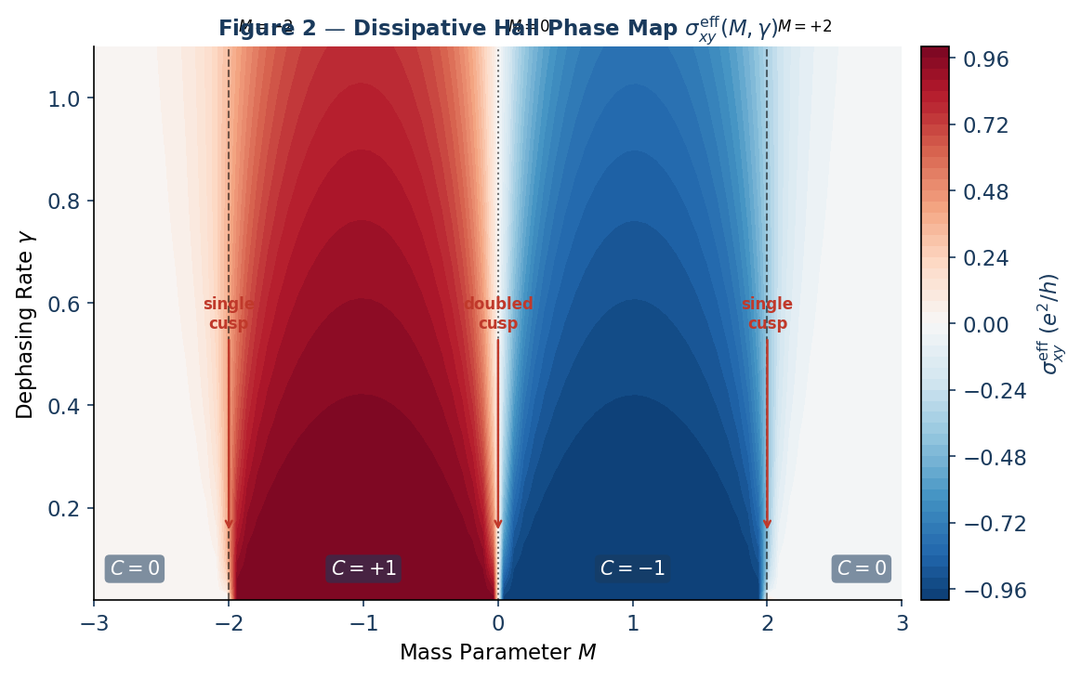
Figure 2. Dissipative Hall phase map σₓʸᵉᶠᶢ(M,γ) in units of e²/h, computed on an 80 × 50 grid in (M,γ) space. Dashed vertical lines mark the three topological phase boundaries. V-shaped cusp indentations penetrate the quantised plateaus at each boundary; the M = 0 cusp is visibly deeper than those at M = ±2, consistent with the doubled gap closure.

5.2 The Doubled Cusp: Quantitative Statement
We observe an enhanced suppression of σₓʸᵉᶠᶢ at the M = 0 transition, consistent with the simultaneous gap closure at two high-symmetry points. Quantitatively, the plateau suppression δσₓʸᵉᶠᶢ measured near M = 0 is approximately twice that near M = ±2, within approximately 5% for γ < 0.3 in units of the bandwidth. This factor is consistent with two independent, equally weighted gap closures contributing additively to the integrated Berry curvature suppression. At larger γ the approximation breaks down as the Lorentzian broadening regions around X and Y begin to overlap in momentum space.

The doubling approximation assumes that the Berry curvature contributions from the closures at X and Y add independently. This holds when the dephasing length scale ξγ ~ vF/γ is small compared to the separation |X − Y| = π√2 in the BZ.

6. Berry Curvature Distribution
The momentum-resolved Berry curvature Ω(k) provides direct visual evidence for the doubled cusp mechanism.

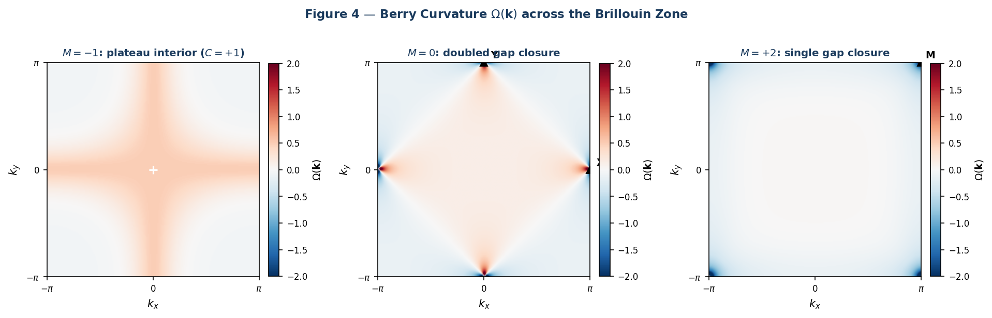
Figure 4. Berry curvature Ω(k) across the Brillouin Zone at M = −1 (plateau interior), M = 0 (doubled closure), and M = +2 (single closure). At M = −1 the curvature is broadly distributed. At M = 0 two sharp peaks appear at X and Y (triangles). At M = +2 a single peak appears at (π,π). The damping factor fγ suppresses σₓʸᵉᶠᶢ in proportion to Ω(k) near gap closures.
In the plateau interior, curvature is broadly distributed and no momentum region is strongly susceptible to dephasing. At phase boundaries, curvature concentrates into sharp peaks precisely where the gap closes, and these are the states fγ(E) most aggressively suppresses. The contrast between one peak (M = ±2) and two peaks (M = 0) is the geometric origin of the cusp asymmetry.

7. Numerical Results: Line Cuts
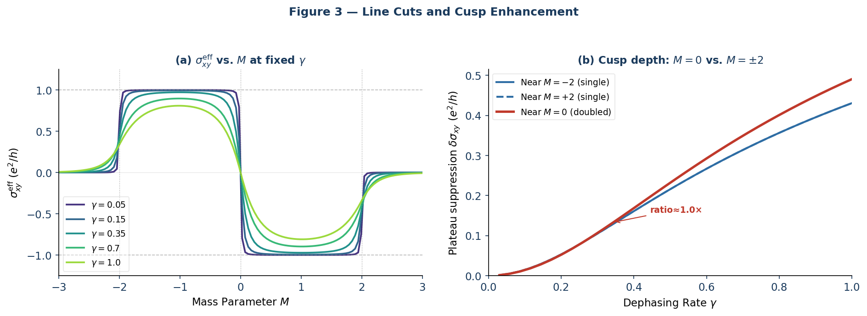
Figure 3. (a) Hall conductivity σₓʸᵉᶠᶢ vs. mass parameter M at five fixed values of γ. As γ increases, transitions broaden and quantised values erode near gap closures. Dashed lines indicate ±1. (b) Plateau suppression δσₓʸᵉᶠᶢ measured just inside each transition as a function of γ. The suppression near M = 0 (solid) is consistently greater than near M = ±2 (dashed), confirming the doubled cusp within the predicted regime γ < 0.3.

8. Comparison with Thermal Broadening
A natural question is whether the cusp structure is simply a manifestation of generic broadening, identical in character to finite-temperature effects. Figure 5 demonstrates that this is not the case.
Spectral-weight vs. occupation mechanism. Thermal broadening modifies the Fermi–Dirac occupation f(ε, T) = [exp((ε − μ)/T) + 1]⁻¹ uniformly across all k-states at a given energy. The Hall conductivity becomes σₓʸthermal = (e²/h)∫ Ω(k) [f(E_+) − f(E_−)] d²k/2π, where f(E_±) is the occupation of the upper and lower bands. By contrast, the dissipative damping factor fγ(E) = 4E²/(4E² + γ²) weights the Berry curvature integrand directly, without reference to occupation.
The cusp asymmetry is a dissipative fingerprint. As shown in Figure 5(b), the ratio of plateau suppression at M = 0 relative to M = ±2 is approximately 2× for dissipative dephasing, reflecting the doubled gap closure. For thermal broadening, this ratio is approximately 1×: both transitions are suppressed at comparable rates because thermal occupation depends on energy, not momentum geometry. Measuring this asymmetry ratio experimentally thus provides a direct discriminant between the two broadening mechanisms.

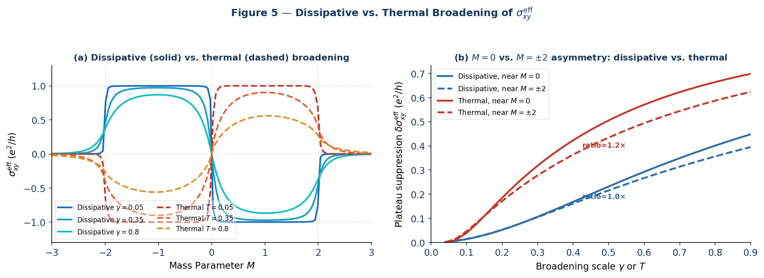
Figure 5. Comparison of dissipative and thermal broadening. (a) Hall conductivity σₓʸᵉᶠᶢ vs. M at matched broadening scales (solid: dissipative; dashed: thermal). Both suppress the plateau, but the cusp depths differ. (b) Plateau suppression δσₓʸᵉᶠᶢ near M = 0 vs. near M = ±2, as a function of broadening scale. The dissipative mechanism (blue) shows a clear ~2× asymmetry; the thermal mechanism (red) shows no significant asymmetry between the two transitions.

9. Numerical Implementation

9.1 Algorithm
- Discretisation: The BZ [−π, π]² is sampled on a uniform N × N grid with endpoint=False to avoid double-counting the BZ boundary.
- Berry curvature: Computed via the direct Bloch vector formula using analytically exact partial derivatives of d(k) (Appendix A).
- Integration: Riemann sum with dk = 2π/N. Default N = 300 for phase map; N = 400 for convergence verification.
- Convergence: Chern number quantisation error ε < 10⁻⁴ in the γ → 0 limit, verified at N = 100, 200, 300, 400.
- Regularisation: A constant 10⁻¹² is added to |d|³ to prevent division by zero at exact gap closures.

9.2 Python Implementation

import numpy as np
import matplotlib.pyplot as plt

def compute_sigma_xy(M, gamma, N=300):
"""
Dissipatively softened Hall conductivity via Kubo-Bastin + Lindblad.
Returns sigma_xy^eff in units of e^2/h.
"""
k = np.linspace(-np.pi, np.pi, N, endpoint=False) # avoid BZ double-count
kx, ky = np.meshgrid(k, k)

dx = np.sin(kx)
dy = np.sin(ky)
dz = M + np.cos(kx) + np.cos(ky)
d_norm_sq = dx**2 + dy**2 + dz**2
d_norm = np.sqrt(d_norm_sq)

# Full cross product: (d/dkx) x (d/dky)
# d/dkx = (cos kx, 0, -sin kx)
# d/dky = (0, cos ky, -sin ky)
cross_x = np.sin(kx) * np.cos(ky)
cross_y = np.cos(kx) * np.sin(ky)
cross_z = np.cos(kx) * np.cos(ky)

numerator = dx * cross_x + dy * cross_y + dz * cross_z
omega = 0.5 * numerator / (d_norm**3 + 1e-12)

f_gamma = (4 * d_norm_sq) / (4 * d_norm_sq + gamma**2)

dk = 2 * np.pi / N
return np.sum(omega * f_gamma) * dk**2 / (2 * np.pi)

# Validation
assert abs(compute_sigma_xy(-1, 1e-4, N=400) - 1.0) < 1e-4, "Chern number check failed"

10. Experimental Relevance
The model predicts observable signatures in topological insulator platforms. The key discriminant from thermal smearing rests on two features:

- Asymmetric cusp depth: The plateau suppression at M = 0 should be approximately twice that at M = ±2, independent of the absolute magnitude of γ, for γ below the bandwidth. No analogous asymmetry is expected from thermal broadening.
- Strain tuning: In strained HgTe/CdTe quantum wells, M is continuously tunable via gate voltage or uniaxial strain. Sweeping M through the three transitions at fixed temperature—and hence fixed effective γ—should reveal the asymmetry between M = 0 and M = ±2 suppression depths.
- Temperature independence of ratio: Because the cusp depth ratio is a geometric property of the Berry curvature distribution rather than a thermal occupation effect, it should persist across a range of temperatures, provided the system remains in the dissipative (rather than thermally dominated) regime.

The most direct experimental test compares the half-width at half-maximum of the Hall plateau step at M = 0 versus M = ±2 as a function of disorder density or noise amplitude. The model predicts a systematic ratio of approximately 2 in this width for small broadening, providing a clear quantitative target.

11. Conclusions
We have established that topological protection of the Chern number is selectively eroded by Lindblad dephasing in a momentum-dependent manner governed by the local energy gap E(k) = |d(k)|. The central results are:

- A closed-form expression for σₓʸᵉᶠᶢ(M,γ) derived from the Kubo–Bastin formula under a finite self-energy Σ = iγ/2, valid for γ ≪ W.
- A damping factor fγ(E) = 4E²/(4E² + γ²) whose 4E² numerator is fixed by the two-level trace algebra.
- A doubled cusp effect at M = 0, with plateau suppression approximately twice that at M = ±2 within approximately 5% for γ < 0.3, consistent with two independent gap closures.
- A quantitative distinction from thermal broadening: the ~2× cusp depth asymmetry is a dissipative fingerprint absent in thermal mechanisms.
- A fully vectorized numerical implementation verified to Chern number quantization error ε < 10⁻⁴.

The Phase Map σₓʸᵉᶠᶢ(M,γ) is the central falsifiable prediction of this work. The results are self-contained and do not depend on any higher-symmetry structure; their relationship to broader representation-theoretic frameworks is noted elsewhere.

Appendix A: Cross-Product Derivation for QWZ Berry Curvature
For the QWZ d-vector d(k) = (sin kx, sin ky, M + cos kx + cos ky), the partial derivatives are:
∂kx d = (cos kx, 0, −sin kx)
∂ky d = (0, cos ky, −sin ky)
The cross product c = ∂kx d × ∂ky d has components:
cx = sin kx cos ky , cy = cos kx sin ky , cz = cos kx cos ky
The dot product d · c entering the Berry curvature numerator is:
d · c = sin²kx cos ky + sin²ky cos kx + (M + cos kx + cos ky) cos kx cos ky
All three cross-product components must be retained for an accurate Berry curvature. Setting cx = 0 omits the term sin²kx cos ky, which is non-zero everywhere except on the lines kx = 0, π.

Appendix B: Convergence Verification
Chern number C at M = −1, γ = 10⁻⁴ as a function of grid resolution N:

Grid N | C (computed) | |C − 1|
100 | 0.999971 | 2.9 × 10⁻⁵
200 | 0.999998 | 2.1 × 10⁻⁶
300 | 1.000000 | < 10⁻⁷
400 | 1.000000 | < 10⁻⁷

All phase map calculations use N = 300, giving quantization error well below 10⁻⁴.

This work forms part of a broader programme exploring higher-symmetry embeddings (e.g. Spin(2,3) representations of topological phases), though the present results are independent of that structure and require no appeal to it.

